**Gibbs Travel Services**

**24th Annual Historical Black College Tour**

**June 18th – 26th, 2019**

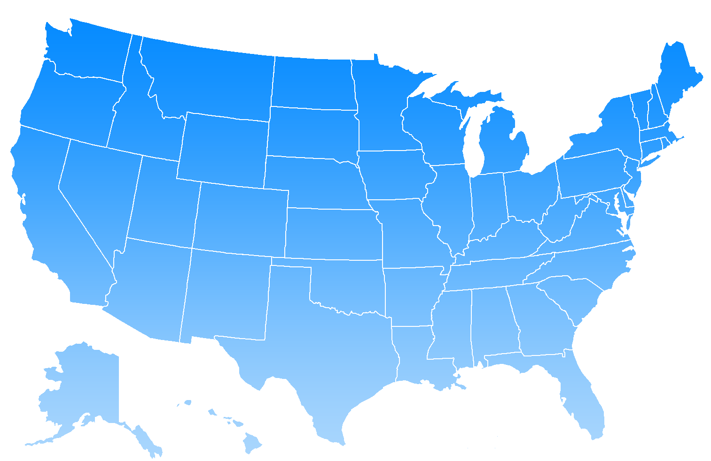

**Alcorn State University** (Lorman, Mississippi)

**Clark-Atlanta University** (Atlanta, Georgia)

**Hampton University\*** (Hampton, Virginia)

**Howard University\*** (Washington, DC)

**Morehouse College\*** (Atlanta, Georgia)

**Norfolk State University** (Norfolk, Virginia)

**Spelman College\*** (Atlanta, Georgia)

**Southern University** (New Orleans, Louisiana)

**Tougaloo College** (Tougaloo, Mississippi)

**Tuskegee University\*** (Tuskegee, Alabama)

**Tougaloo Mississippi (Tougaloo College)**

**Tuskegee Alabama** (*Tuskegee University)

**Washington D.C.,** *(*Howard University)*

*(*\*Ranked as one of the top ten HBCU’s according to US News and World Report 2017)

*\**

*Indicates the college/university is ranked/listed as one of the “Top

Ten HBCU’s” *-U.S.News & World Report LP. Best HBCU 2012 Rankings-*

Tallahassee, Florida *(Florida A & M)*

Tuskegee, Alabama *(Tuskegee University)*

Atlanta, Georgia *(Clark-Atlanta, Morehouse, Spelman)*

Greensboro, North Carolina *(North Carolina A & T, Bennett College)*

Washington D.C., *(Howard University, Morgan State University)*

*\*\*\* \*\*\*\** Hampton, Virginia *(Hampton University, Norfolk State*

Nashville, Tennessee *(Tennessee State University, Fisk University)*

[](http://www.google.com/url?sa=i&rct=j&q=choosing+the+right+college&source=images&cd=&cad=rja&docid=yIA7sFvv-AxR0M&tbnid=Hdw77blTppc49M:&ved=0CAUQjRw&url=http://www.c2educate.com/blog/choosing-the-right-college-a-step-by-step-guide/&ei=BfX4UZC5M_SEygG-woHABw&bvm=bv.49967636,d.aWc&psig=AFQjCNGv5RPquSO6JJrD4Cv6Lr3g8e436A&ust=1375356535017453) 

* Roundtrip Motor Coach Transportation
* Hotel Accommodations
* Buffet Breakfast & Lunch on Campus
* Tour and Speak with Admission Counselors
* See Historic Washington D.C sites

(White House, Washington Monument,

National Mall, etc.)

* Attend Ebenezer Church in Atlanta, Georgia
* Tour Martin Luther King Center
* Admission to Six Flags over Georgia
* Tuskegee Airmen Museum…….and much more

**RESERVATIONS, DEPOSITS, PAYMENTS & CANCELLATIONS**

1. A deposit of $75.00 is required to make and hold a reservation if made on or before October 31, 2018.
2. Reservations made after October 31st 2018 requires a $150.00 deposit.
3. Final payment is due on or before May 5, 2019.

\*\*\***Advance payments or payments in full may be made at any time\*\*\***

**CANCELLATIONS:**

1. Cancellations made **before** February 8, 2019 will receive full refund less a $25.00 cancellation fee.

2, Cancellations made on February 8, 2019 and before March 15, 2019 will receive refund less a $100.00 cancellation fee.

3. Cancellations made on or after March 15, 2018 will result in no refund being awarded.

$875 *PER PERSON, BASED ON QUADS*

“The beautiful thing about learning is that no one can take it away from you.” B.B. King

Making a college visit and touring the campus can be pivotal in a student’s decision to attend college. Students will meet and speak with admissions and/or financial aid representatives. Students are encouraged to ask questions and not only listen to the answers, but take in the authenticity of the answers, pick-up the school spirit, and the school’s culture and community. Not only does the tour visit colleges, it also includes sightseeing and visits of historical places.

**Space is limited!**

**INCREDIBLE PRICE INCLUDES:**

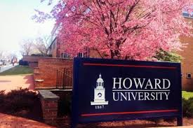  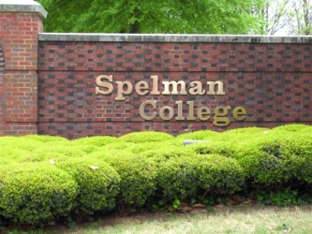 [](http://www.google.com/url?sa=i&rct=j&q=&esrc=s&source=images&cd=&cad=rja&uact=8&ved=0ahUKEwiU-7fryojOAhWCSCYKHUVBBCIQjRwIBw&url=http://directory.origindirectory.com/listing/hampton-university/&psig=AFQjCNGs05QLNs8p7vrzgHtxOhEK9C_bfw&ust=1469328894738359)

**For More Information or to register Please Contact:**

**Please Return This Portion or Register Online**

First Name_________________________________________________ MI _____ Last Name____________________________________________________ Circle: Male or Female

Address_______________________________________________________City____________________ State ____________ Zip_______________________ High School ______________________________

Grade this school year________________ Email Address _______________________________________________________________ Phone ______________________________________________

Name of Parent/Guardian____________________________________________ Email__________________________________________________ Phone____________________________________________

**Make checks/money order payable to:**

Gibbs Travel Services

P.O. Box 300231

Houston, Texas 77230-0231

or

Register online at

**www.gibbstravelagency.com**

**713-748-2242 or www.gibbs_travel@yahoo.com**

Gibbs Travel Services LLC

713-748-2242 or visit our website:

www.gibbstravelagency.com

**Parents are invited to attend the tour!**